1. **What is Devops**

* Basically, Devops is Development + Operations. Devops is process and having lots of tools to accomplish the same.

It is agile, collaboration of IT development and operations which is more of cultural shift.

Which is related to agile methodology

Priorities-resource mgnt, communication and teamwork

Benefits-Speed, functionality, stability and innovation

1. **Explain your day to day activities.**

* Git : Create repository, branches, Issues, merge code if needed.
* Jenkins – Create jobs, build, user, build result issues with build code, troubleshooting with log file or console output.
* Delevery – tomcat, backup,
* Documentation – of build and release peocess
* KT to new comers and its documentation
* Daily status call with client
* Backup

1. **Essential tools of devops and which you have used**
   * SCM tool- GIT, SVN
   * Continuous Integration tool – Jenkins, Teamcity, bamboo etc
   * Selenium for Continuous Testing
   * Configuration management tool : Ansible/chef/puppet
   * Containerization – Docker
   * Monitoring - Nagios
2. **What is CI**

* CI is the process of integrating the code which is developed by the developers. A developer required to commit the code into repository several time in a day or frequently into the repo.
* Every commit made build.
* This allows the team to detect problems early.
* So that, its less time consumes.
* Apart from this, depending upon the CI tool, there are several other functionalities are provided like deploy the application into test server.

1. **What is CD (Continious Delevery – is the deployment of software but customer approval is required)** CI + software release process is automated. JIRA tool is used and CAB approval is neede.

CD is the concept that says that all code that is pused into the repository is ready to deploy at any time. Kowing the feature is ready. Normally means having a test to ensure it works properly. If the feature is isn’t ready or working properly the it should be hidden from client i.e dark launching.

1. **What is Continious Deployment (Automated – No need of customer approval is required)**

CI + CD + fully automated deployment to production.

1. **SDLC phases with description**

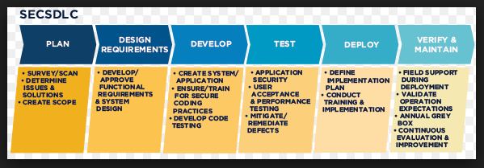

* 1. **Reuirement gathering** and analysis– Gather business reuirement. Main focus is project manager and stackholders. servey, determne issues and solutions, Create scope and create requirement speacification document.
  2. **Design** – system requirement – hardware and software speacification and overall system requirement, approve functional requirement.
  3. **Develop** – divide into the modules / units and Create / develop application using the programming languages. (Longest phase)
  4. **Testing** – Test the application whether it is bug free or not. Check whether the all requirement are addressed or not. Check whether it is meeting the expected requirements or not.
  5. **Deploy** – Deploy the code/system into the production.
  6. **Maintainance** – Field support during deployment. Validate operation and exceptions. Continuous evaluation and improvemrnt.

Envirnoments:

1. Dev
2. Test
3. UAT
4. SIT
5. Pre - pod
6. Production